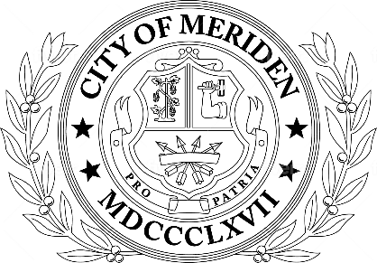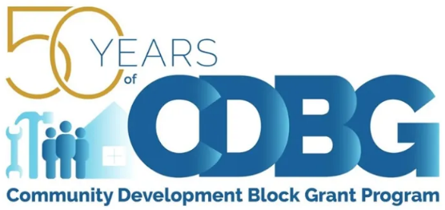

In addition to an online submission, a printed version along with required attachments MUST be delivered by mail or hand-delivered by Friday, April 26, 2024 at 5pm.

Part 1. Application Summary

  - Program/Project: *
  - Agency Name: *
  - Authorized Official First Name: *
  - Authorized Official Last Name: *
  - Authorized Official Email Address: *
  - Address Line 1:
  - Address Line 2: *
  - City: *
- State: *
- Zip Code: *
- Agency Federal UEI Number: *
- Agency Fed Tax ID (EIN) XX-XXXXXXX: *
- Grant Contact First Name (if different from Authorized Official listed above). If blank, enter N/A *
- Grant Contact Last Name (if different from Authorized Official listed above). If blank, enter N/A: *
- Grant Contact Title: *
- Authorized Official Title:
- Grant Contact Telephone:
- Grant Contact Email Address: *
- Amount Requested: *
- Total Project Cost: *
- Will another entity besides the applicant be administering the project? *

Part 2. Applicant Eligibility

- Entity Type: *
☒ NPO w/ 501c(3) status or equivalent
☐ Faith-based NPO
☐ Other
- Previous CDBG Grants Received by Year, Amount and Purpose (Newest to Oldest): *

- Grant Type:
☐Public Facilities Improvements (Acquisition, Construction, and Rehabilitation
☐Public Services (Programs and Projects Delivering Services)

- If "Public Services" was selected, please confirm the agency's primary beneficiary below, if applicable): *

☐People Experiencing Homelessness ☐People Experiencing Abuse
☐People with Special Needs (Elderly, People with Disabilities, People with Substance Abuse Disorders)
☐People with Low-to-Moderate Income

- CDBG requires the grant funds utilized for the project/program to primarily benefit low to moderate income persons (at least 51% or more). Please describe your income eligibility screening process, including the methodology used: *

- Number of people/households to directly benefit from your program or project (## people, ## households): *

Part 3. Program/Project Description

- Program/Project Details - What is the need or problem the program/project seeks to address? Include the major activities and/or scope of services to be delivered as part of the program/project. Also, describe how the program/project will meet the Consolidated Goal Plan: *

- Program/Project Goals - Briefly describe expected project goals, and your evaluation method for monitoring progress: *

- Program/Project Timeline - Provide a timeline for the implementation plan of the proposed project, assuming availability of CDBG starting July 1. Describe the implementation plan for the project by listing the key tasks and milestones. Be sure to include program start and completion dates.

First Quarter: July 1-September 30, 2024
Second Quarter: October 1-December 31, 2024
Third Quarter: January 1- March 31, 2025
Fourth Quarter: April 1-June 30, 2025

If the program/project period of performance is expected to run less than 12 months, please reflect this in the timeline accordingly: *

Part 4. Program/Project Budget
Please download the budget template and include expenses for the project or program activity
<https://www.meridenct.gov/government/departments/economic-development/community-development/>.

- Budget Narrative - Please provide a brief explanation for each expense

Part 5. Required Attachments to be submitted via email to jallam@meridenct.gov.

- IRS Tax-Exempt Determination Letter
- IRS Form 990
- UEI Status from SAM.gov
- Certificate of Insurance
- Audited Financial Statements or Certified Financial Statement Review
- Conflict of Interest Disclosure Form for each board member and program/project staff
- Budget Form and Narrative

Part 6. Application Certification
- THE UNDERSIGNED CERTIFIES THAT:
  - The information contained in this document is complete and accurate;
  - The proposed program/project described in this application will meet the National Objective of benefiting low- and moderate-income persons, as defined by the CDBG Regulations at 24 CFR Part 570;
  - The applicant shall comply with all Federal, State and City laws, and CDBG Program requirements;
  - If the project is a facility improvement, the sponsor shall maintain compliance with 24 CFR 570.505; and
  - Sufficient funds are available from non-CDBG sources to complete the project as described, or operate the program through the program year end on June 30, 2025, if CDBG funds are allocated to the applicant.
  - DISCLAIMER: By typing your name below, you are signing this application electronically. You agree your electronic signature is the legal equivalent of your manual signature on this application.

Signed Name & Title of Authorized Official & Date *

Authorized Official Signature Date

